4. Decision Structures and Boolean Logic
The if Statement
CONCEPT: The if statement is used to create a decision structure, which allows a program to have more than one path of execution. The if statement causes one or more statements to execute only when a Boolean expression is true.

name = input('What is your name? ')
age = int(input('What is your age? '))
print('Here is the data you entered:')
print('Name:', name)
print('Age:', age)

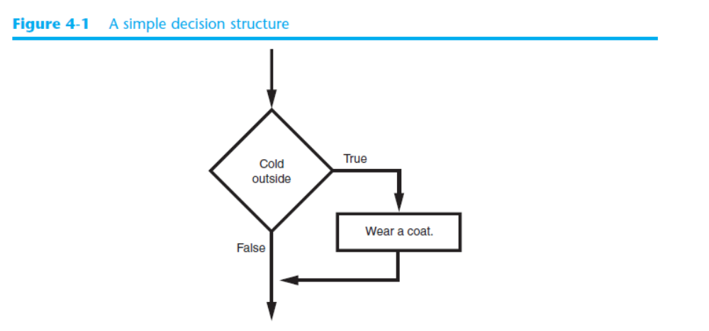

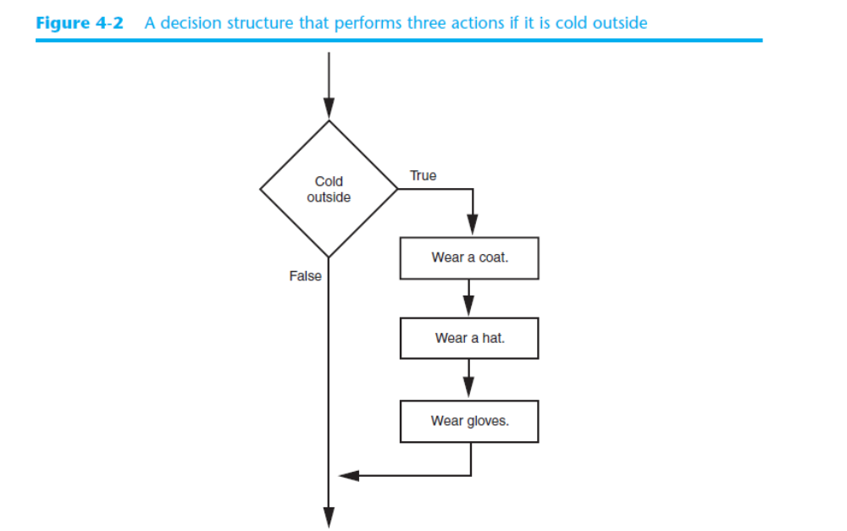

In Python we use the if statement to write a single alternative decision structure. Here is
the general format of the if statement:
if condition:
statement
statement
etc.

Boolean Expressions and Relational Operators

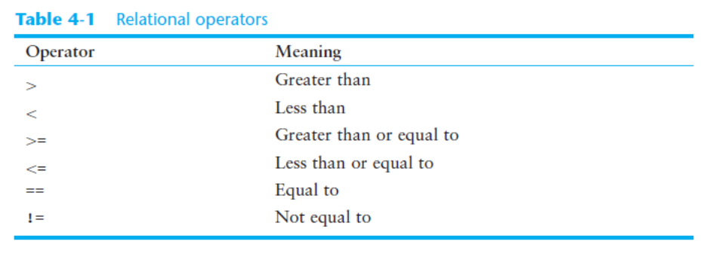

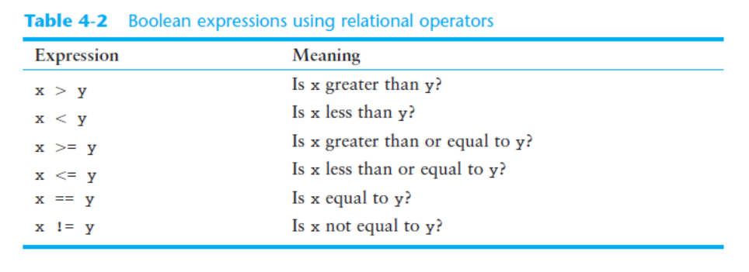

if sales _ 50000:
bonus = 500.0

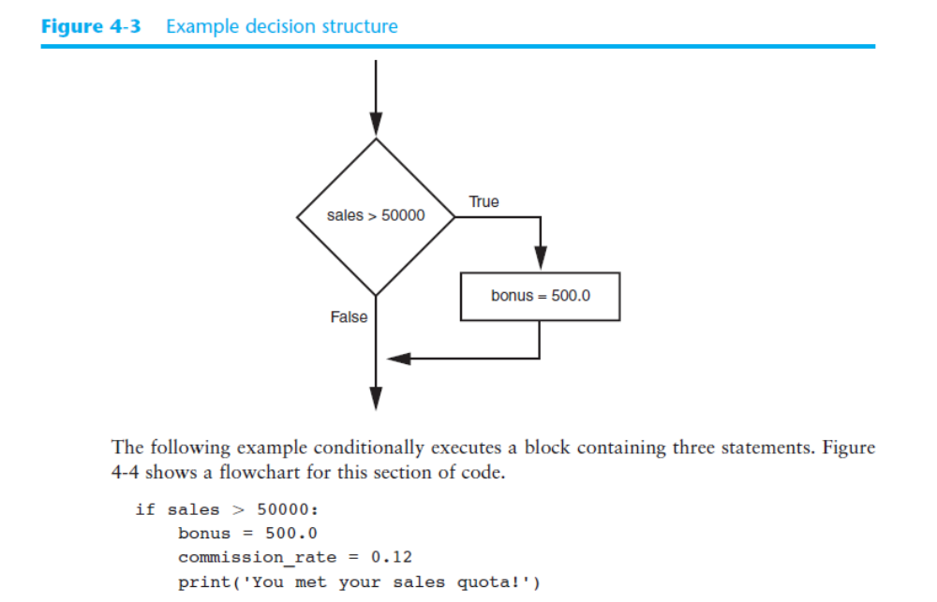

4.2 The if-else Statement

CONCEPT: An if-else statement will execute one block of statements if its condition is true, or another block if its condition is false.

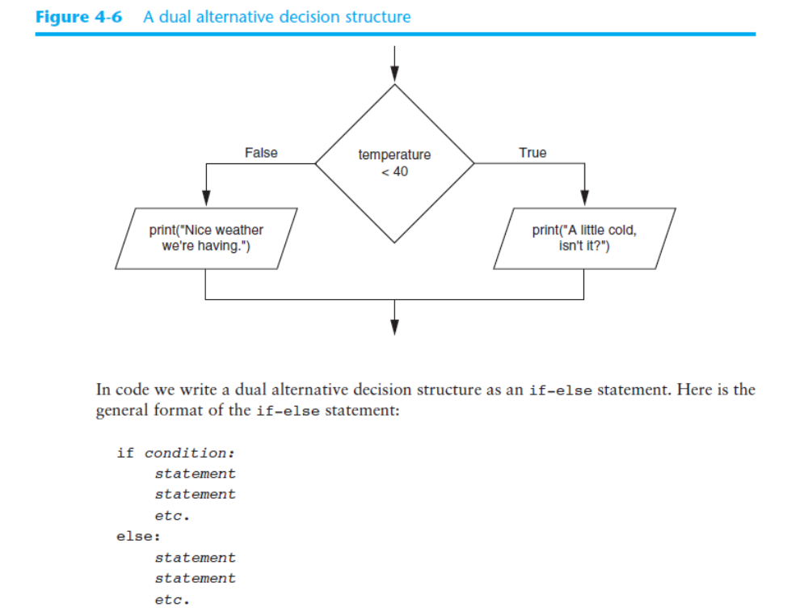

if temperature _ 40:
print("A little cold, isn't it?")
else:
print("Nice weather we're having.")

4.3 Nested Decision Structures and the
if-elif-else Statement

CONCEPT: To test more than one condition, a decision structure can be nested inside another decision structure.

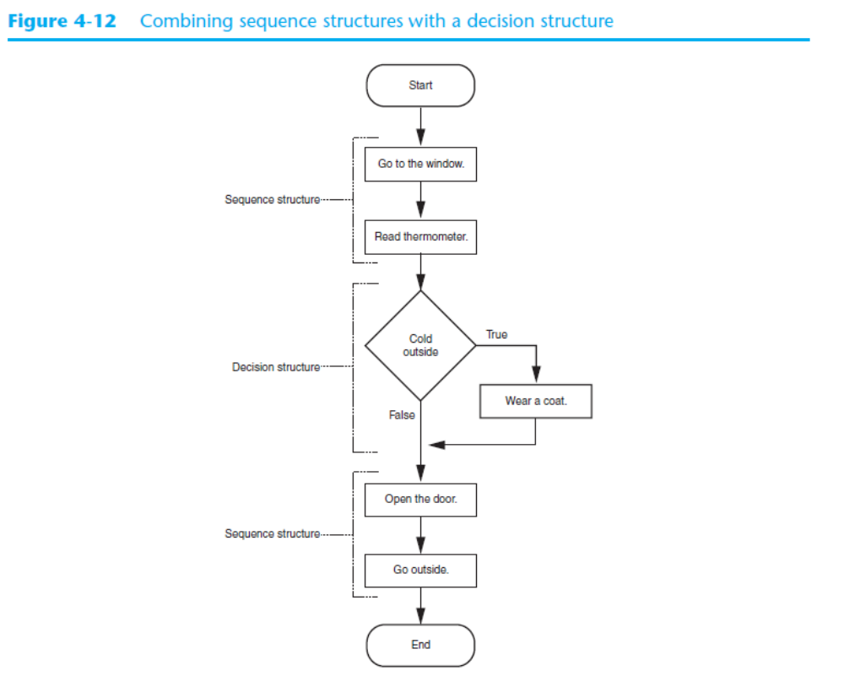

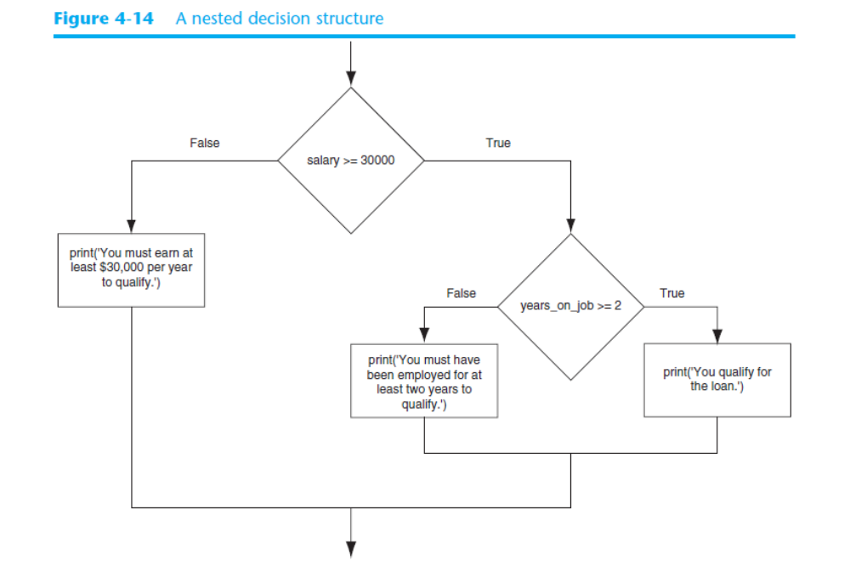

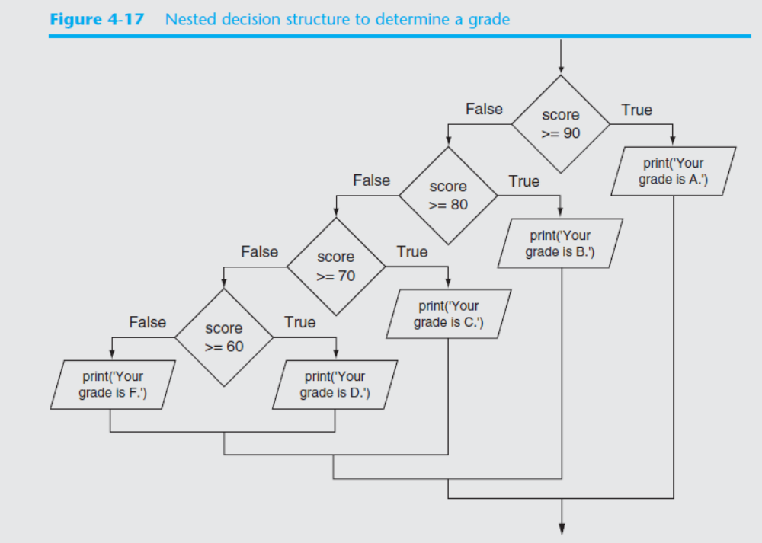

Logical Operators

CONCEPT: The logical and operator and the logical or operator allow you to connect multiple Boolean expressions to create a compound expression. The logical not operator reverses the truth of a Boolean expression.

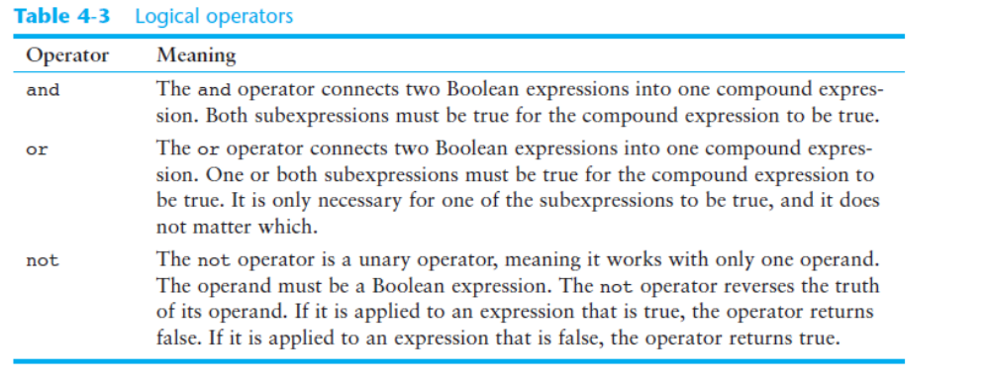

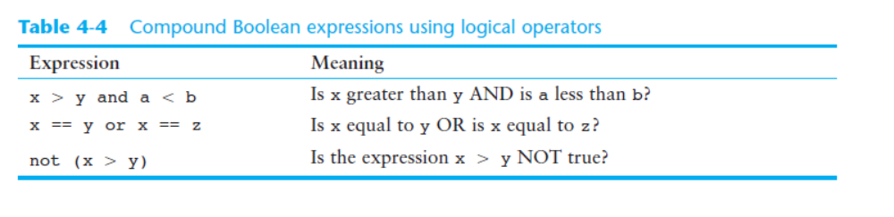

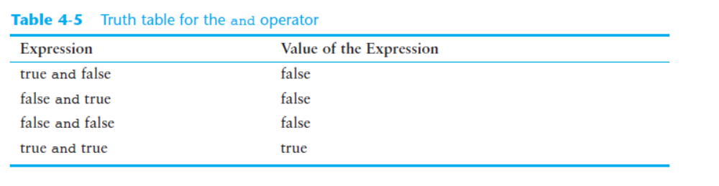
The not Operator
The not operator is a unary operator that takes a Boolean expression as its operand and reverses its logical value. In other words, if the expression is true, the not operator returns false, and if the expression is false, the not operator returns true. The following is an if statement using the not operator:
if not(temperature _ 100):
print('This is below the maximum temperature.')

